Monday 6th October 2025

To Parents of Year 5 & 6 children,

We are pleased to let you know that every child in UKS2 now has access to their own locker for storing belongings during the school day. These lockers are provided to keep classrooms and corridors tidy, and to ensure that children’s belongings are kept safe. As many secondary schools provide lockers of a similar size, this is good practice for pupils to become familiar with managing their belongings independently.

However, it has been noticed that:

- Some belongings are being left on the floor rather than in lockers.
- Some children are using more than one locker, meaning others do not have access to their own.
- Some belongings are too large to fit into the lockers provided.

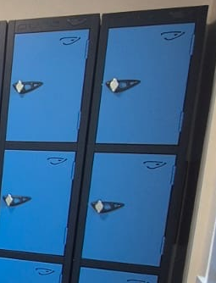
To ensure that lockers are used fairly and effectively, we ask for your support in making sure that your child only brings the following items into school each day:
- A reading book
- A packed lunch box
- A snack
- A coat (please ensure it is small enough to fit inside the locker – see picture attached)

Additional guidance:

- Mobile phones should only be brought in by children who walk home independently and have a signed “Walking Home Consent Form” on file with the office. Phones must be handed to the class teacher on arrival and will be kept safely until the end of the school day.
- Pencil cases are not required, as the school provides all the equipment your child needs for learning.
- Keychains, toys and money should not be brought into school.

We appreciate your cooperation in helping us to maintain a safe, organised environment for all children. By working together, we can ensure that lockers are used properly and that every child benefits from this system. If their belongings do not fit in a locker, they need to change what they are bringing into school.

Thank you for your continued support.
Mrs B Brackenbury
UKS2 Phase Leader, Maths Leader & Year 6 Teacher

