Match the characteristics of two pictures amongst other similar pictures.

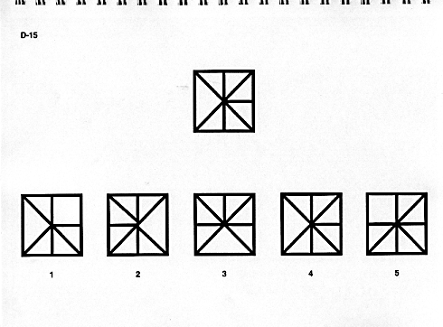

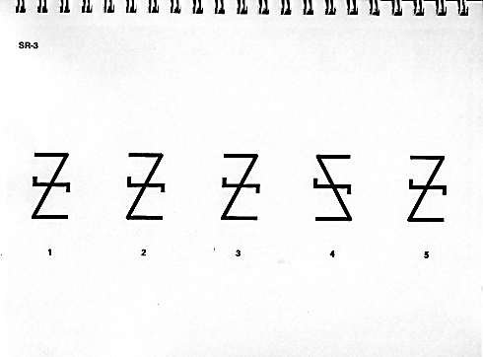
Visual form constancy is the ability to recognise a form even when it is larger, smaller, rotated, reversed or partially hidden.


