Book List
Rosa Parks (Little People, Big Dreams) by Lisbeth Kaiser, Malalas magic Pencil -Malala YousafzaStone Girl/Bone Girl - Laurence Anholt
Man on the Moon- Simon Bartram

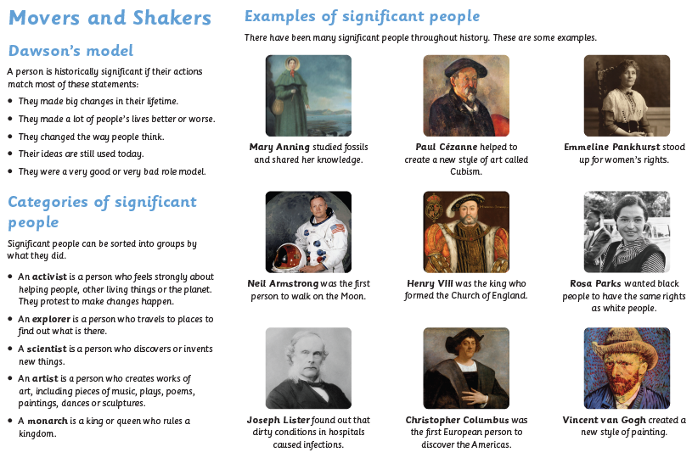
Key questions
How can we use historical resources to find out about the past? What impact has been made on the world by historically significant people?
What is a timeline?


