All Saints C of E School



RWI Support Materials

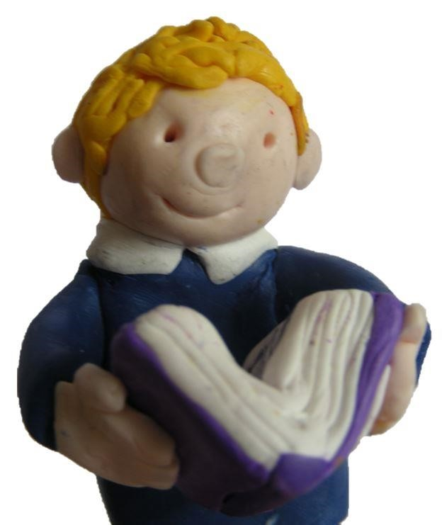

Outline of Materials
The following pack of materials is to help you support your child at home with their phonics journey. The first pages can be used as they are, or could be laminated and cut up to use with your child to help them practise the sounds they are learning. Please check the Ruth Miskin website for other parent support materials and videos, including how to pronounce the phonemes accurately! http://www.ruthmiskin.com/en/parents/
The children follow this progression in learning phonics:
 |  |  |  |  |  | Speed Sounds Set 1
m | a | s |  | d |  | t |  | i |  | n |  | p |  | g |  | o |  | c |  | k |  | u |  | b |  | f | e
l | h | sh |  | r |  | j |  | v |  | y |  | w |  | th |  | z |  | ch |  | q |  | x |  | ng |  | nk
 |  |  |  |  |  | Speed Sounds Set 2
ay ee |  |  |  | igh |  | ow oo oo ar or |  |  |  |  |  |  |  |  |  |  |  |  | air ir |  |  |  |  |  | ou |  | oy
 |  |  |  |  |  | Speed Sounds Set 3
ee | ea |  | oy |  | oi |  | ay |  | a-e |  | igh |  | i-e |  | ow |  | o-e |  | oo |  | u-e |  | or |  | aw |  | air
are | ir |  | ur |  | er |  | ou |  | ow |  | ai |  | oa |  | ew |  | ire |  | ear |  | ure |  | tion |  | cious |  | tious

Alongside these they also learn red words (tricky words), which are difficult to blend but are key words they need to read and access texts (eg. the, said, your).
You will find the green words are printed in order. The children work through set 1 sounds before moving on to set 2, and then the same for set 3. You will notice that we have put dots and lines under the different sounds – this is to help the children identify the phoneme and sound it out:
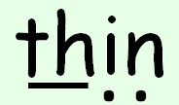
A line is placed under a phoneme that has more than one letter for the corresponding grapheme (a digraph, or trigraph).
A dot is placed under a phoneme that has only one letter for the corresponding grapheme (graph).
How to read and practise the words:
Green words:
Use Fred Talk – point with your finger under each phoneme as you make the sound, then run your finger under the whole word to blend those sounds together to say the word.
Over time, as they get more confident, encourage them to instant sound blend so they are saying the sounds in their head quickly then saying the word out loud.
Red words:
The children should be told these words and practise sight reading them (without blending).
We have printed the following on one side of the page so that you could laminate / cut them up and use as flash cards for games and practise. Alternatively, you can use them as they are – but please do not go on to the next words before your child moves on at school – this could be confusing for them.
If you have any questions, just ask Miss Andrews or Mrs Lapham and we’ll be happy to help!

Simple Speed Sounds Chart (for Set 1 and Set 2 Sounds)

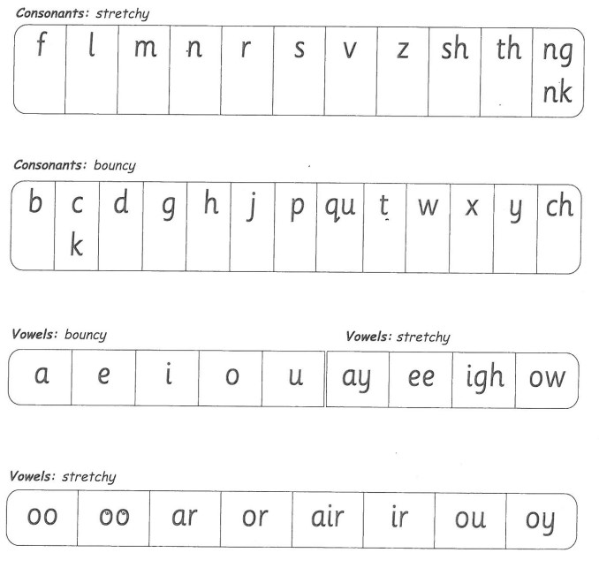

Complex Speed Sounds Chart (for Set 3 Sounds)

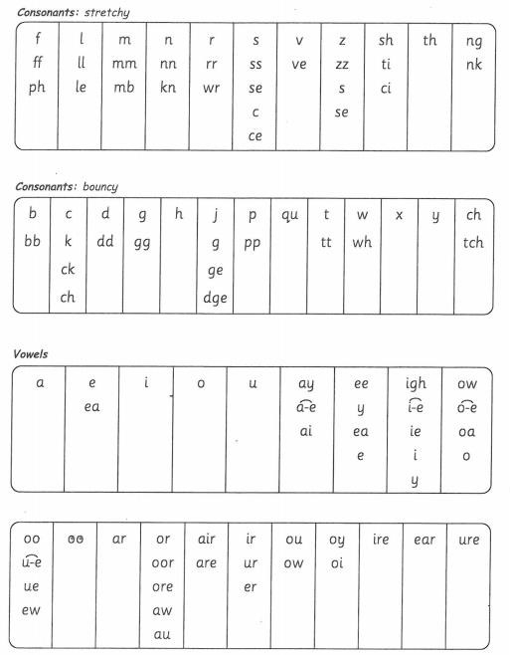

Red Words (Tricky Words)
Red for a while words These include graphemes that have not been taught by the time they are needed in the reading books. As soon as the grapheme has been taught, each of these turn into a green word! Practise these so they can read them by sight (not blending). You could cut them out to use for games (laminating might be useful!).

he | me | we
she | be | no
so | go | old
her | saw | my
by | why | now
how | down | over
school
Other Red Words:
I | the | you
your | said | was
are | of | want
they | to | do
does | all | call

tall | small | any
many | anyone | some
come | watch | who
where | there | here
were | brother | other
mother | father | love
above | two | once
buy | worse | walk
talk | caught | bought
thought | through | wear
whole | could | would
should | great | son
water

Set 1 Sounds
1.1
at | mat | sat
mad | dad | sad

1.2
gap | pan | top
got | dog | ^{pin}
^{tip} | pig | ^{dig}
^{sit} | it | ^{in}
on | and | ^{an}

1.3
^{up} | cup | mud
^{kit} | bed | get
met | ^{bin} | bad
cat | can | cot

1.4
hen | ^{hit} | had
fan | ^{fat} | ^{log}
shop | fun | lip
fish | ship | ^{let}

1.5
^{jet} | wet | vet. . .
yes | ^{wish} | web
yet | jam | yap
jog | ^{win} | yum
rat | red | run

1.6
wing | chin | thick
chop | chat | quit
quiz | sing | thing
bang | this | thin
fix | six | ^{zag}
zip | fox | box

1.7
stink | wink | back
^{skin} | slid | ^{slip}
^{grin} | ^{prop} | ^{pram}
from | ^{clip} | gran
hand | ^{stand} | stamp
flop | frog | ^{jump}
black | flag | think
^{skip} | best | trip
^{blob} | ^{brat} | drip
^{drop} | blip | fluff
dress | huff | mess
test | trap | ^{spit}
stop | ^{spot} | strop

Set 2 Sounds
2.1
pl ay | may | say
day | way | spray
2.2
see | been | seen
three | green | sleep
2.3
high | light | bright
night | fright | might
2.4
^{bl} ^{ow} | low | know
^{sn} ow | show | ^{sl} ^{ow}

2.5
too | food | moon
zoo | poo l | spoon
2.6
took | book | coo k
loo k | shook. | foot
2.7
car | part | ^{hard}
start | star | sharp
2.8
s ort | short | horse
spor t | ^{f} ^{ork} | snort

2.9
fair | hair | chair
stair | air | lair
2.10
girl | bird | third
whirl | twirl | dirt
2.11
out | shout | loud
mouth | round | found
2.12
toy | boy | ^{enjoy}

Set 3 Sounds
3.1
clean | dream | seat
scream | please
3.2
joi n | v oice | coin
3.3 | 
^{make}  ) |   ^{cake}  ) | ^{name}  )
^{same}  ) |   late  ) | ^{date}  )
3.4

^{smile}  ) | white  ) | ^{nice}  )
^{like}  ) |   ^{time}  ) | ^{hide}  )
3.5
^{home}  ) | ^{hope}  ) | ^{spoke}  )
^{note}  ) | ^{broke}  ) | phone  )

^{rude}  ) | brute  ) | ^{June}  )
3.7
saw | l aw | ^{d} ^{awn}
crawl | paw | yawn
3.8
share | dare | sc are
square | bare | care
3.9
^{burn} | ^{turn} | ^{spurt}
nurse | purse | ^{hurt}
3.10
never | better | Weather
after | ^{proper} | corner
3.6

3.11
how | down | brown
cow | town. | now
3.12
paid | train | pai nt
rain
3.13
goat | boat | road
throa t | toast | coat
3.14
chew | new | blew
flew | drew | grew
3.15
fire | hire | wire
bonfire | insp ire | conspire

3.16
hear | dear | fear
near | year | ear
3.17
picture | mixture | creature
future | advent ure | temperat ure

3.18
delici ous | suspici ous | vicious
^{scrumptious} | precious | ferocious
^{tradition} | attention | ^{celebration}
conversation | ^{congratulation} | exploration

