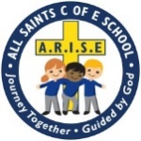
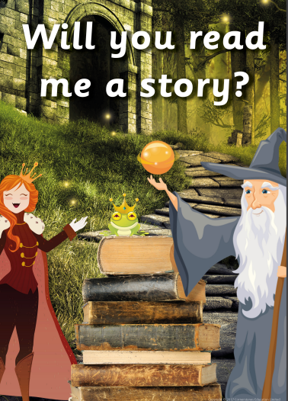
Useful Words
Story Fantasy
Goody Baddy
Hero Villain
Witch Knight
King Queen
Prince Princess
Castle Wish
Recommended reads:
- Goldilocks and the 3 bears
- Jack and the Beanstalk
- The 3 little pigs
- The gingerbread man
- The Gruffalo
- Little Red Riding Hood
Was Goldilocks a good or bad character?

Was the big bad wolf really that bad?
Do all fairy tales have good and bad characters?
Supporting your child at home
- Read lots of classic fairy tales and stories. Talk about what happens in the story and describe the characters. Encourage your child to tell their own story using a beginning, middle and end.
Useful websites
- Reception / EYFS: Listen and Play - Traditional Tales - BBC Teach
- Musical Storyland - music and fairy tales for families with young children - CBeebies
- Free Bedtime Stories, Fairy Tales, Online Storybooks and Audio Books for Kids! | Bedtime Stories
FS2
T5

