
Homework pieces/ evidence should be handed into school on the first day back in the new term. Please make sure you have your name on them. Have fun! From the KS1 Team
How it Works
You simply need to pick your homework, aiming to spend at least 12p in total.
Year 1 Pick ‘n’ Mix Easter Homework

3p  Make your own Easter treats with an adult and write instructions on how to make them.   |   Practice your beautiful joined up handwriting on LetterJoin at home daily!  5p |   1p  Find items around your house and write sentences to compare the weight. |   Put some of the following words into sentences  You, the, me, my, school  1p
2p  Go on a spring walk and look for signs of new life. Keep a record of the things you saw.   |   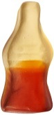  Retell the Easter story through Art or writing.  4p |     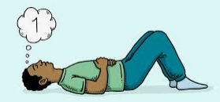  Listen to some gentle music and use this time to reflect on what makes you happy. |   Culture Vulture  Can you name 3 landmarks that you would see in London?  5p
5p     | 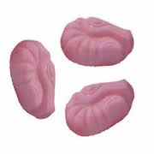  Write down 5 adjectives to describe where you live e.g. gigantic, old, beautiful.  1p |   2p  Culture Vulture  Draw a picture to show what happened during the Great Fire of London.  2p |   Practise doubling numbers up to 10 eg double 1 = 2, double 2 = 4. Then practise halving numbers e.g. half of 6 is 3  3p

